**Lesson 04 Demo 1**

**Using Measure names and Measure values**

* What is the overall sales of the East region a couple of years back? (**Note**: Add a filter for the East region and add subtotals)
* What is the aggregated profit ratio for Binders four years back in the Central region?

(**Note**: Add a filter for the Central region).

**Overview:**

* Create a highlight table with year, subcategory, and all the measures
* Enable color legends per measure
* Apply a quick filter on measure names

The result should resemble the image given below:

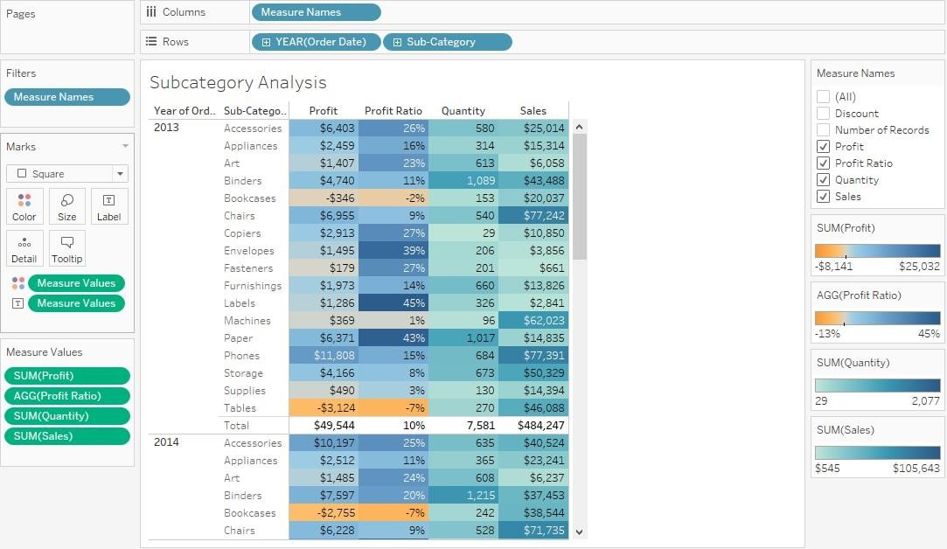

**Detailed Instructions:**

1. Open **Tableau 10.x** (You can go to Start Menu -> All Programs -> Tableau 2021.4)

1. From the home page, connect to the saved **Sample - Superstore** dataset

1. From Dimensions, drag **Order Date** and **Sub-Category** to the **Rows** shelf

1. From Dimensions, drag **Measure Names** to the **Columns** shelf

1. From Measures, drag **Measure Values** to **Text** shelf and **Color** Shelf in Marks card

1. To convert the view to a Highlight Table, change the **Marks** type to **Square**

1. To enable the filter, right-click on the **Measure Names** field in the **Columns** shelf and select **Show Filter**

**Note**: The Show Filter option shows the following window.

1. Uncheck **Count of Orders** and **Discount** in the show filter control

1. To add **Profit Ratio**, go to the **Analysis** pane and select **Create Calculated Field**

1. In the **Calculated Field** window, in the Name box, write **Profit Ratio,** and in the **Formula box**, type **SUM([Profit])/SUM([Sales])**

1. Click **OK**

1. Drag **Profit Ratio** to **Measure Values** under **SUM(Profit)**

1. Click on **AGG(Profit Ratio)** in **Measure Values** and select **Format**

1. In the **Pane** window, under **Default,** click on the drop-down of **Numbers,** select **Percentage,** and decrease the **Decimal** places to 0

1. In **Measure values,** click on **SUM(Profit)** and select **Format**

1. In the **Pane** window, under **Default**, click on **Numbers** drop-down, select **Currency (Standard)** drop-down, and change it to **English (United States)**

1. Select **Currency(Custom)** and decrease the **Decimal value** to 0

1. In **Measure Values,** click on **SUM(Sales)** and select **Format**

1. In the **Pane** window, under **Default**, click on **Numbers** drop-down, select **Currency (Standard)** drop-down, and change it to **English (United States)**

1. Select **Currency (Custom)** and decrease the **Decimal** value to 0

1. To enable color legends per measure, right-click on **Measure Values** in the **Color** shelf and select **Use Separate Legends**

**Note**: The Color Legends are enabled.

1. Rename the worksheet as **Subcategory Analysis**

**Note**: Keepthe workbook open for the next exercise.

**Answers:**

Based on the view, these are the answers to the questions in the problem statement:

* + What is the overall sales of the East region in2014?

Answer: **$128,680**

* + What is the aggregated profit ratio for Binders in 2016 in the Central region?

Answer: **21%**